**Theme Design**

1. **Button**

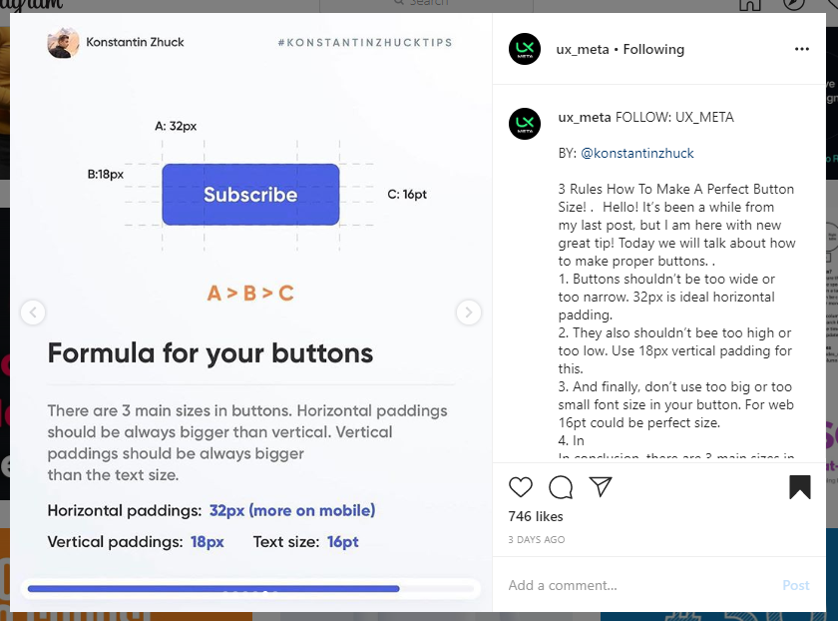

1. **HTTP**

Use http, dio, requests.

1. Bottom navigation bar

